**“Experiment 3.3”**

**Aim:**

Study the Implementation of Zigbee Protocol using Raspberry Pi/Arduino.

**Introduction**

XBee wireless transceivers provide a quick, easy way to add wireless communication to any system. This page will outline how to set up two XBee Pro Series 2 transceivers for communication with each other.

**Hardware Required:**

1. 2 XBee Pro S2 Transceiver
2. 2 UART to USB adapter board
3. 1 USB Cord

**XBee Wireless Communication Setup**

**Step 1:** **Download X-CTU Software**

The X-CTU software is free to download and provides a simple interface to configure and update your XBee transceivers. With this software firmware updates are a breeze and configuration is simple. The software can be downloaded from Digi’s website.

**Step 2:** **Put together your XBee breakout board**

The XBee transceivers have a 2mm pin spacing, which does not allow them to be plugged into a standard 0.1-inch breadboard. There are, however, several different breakout boards available that allow the transceiver to be inserted into a breadboard. The various adapter boards also allow for connection through USB or serial to your computer. The breakout board used here has a UART to USB conversion circuit and allows the XBee to be connected to the computer and XCTU software easily.

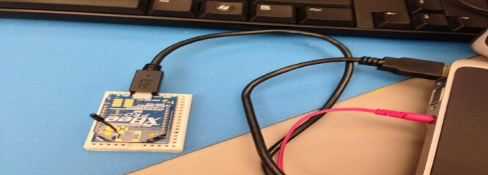

**Step 3: Configure 1st XBee as a coordinator**

When opening the X-CTU software you should see a window like that shown. After selecting the proper COM port click the Test/Query button.

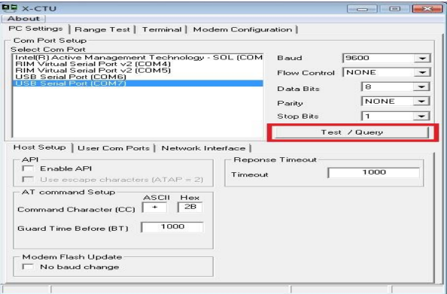

After selecting the Test/Query button, you should see a dialogue box like the one below. You will want to record the serial number shown, as you will need it in a couple minutes.

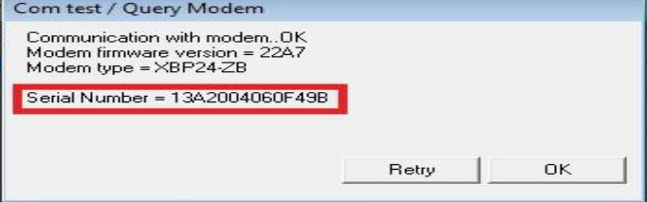

After recording the serial number you can click OK. Next, select the Modem Configuration tab at the top of the window. Once here, select the read button. This will bring up the current configuration for the connected XBee and will be similar to the following:

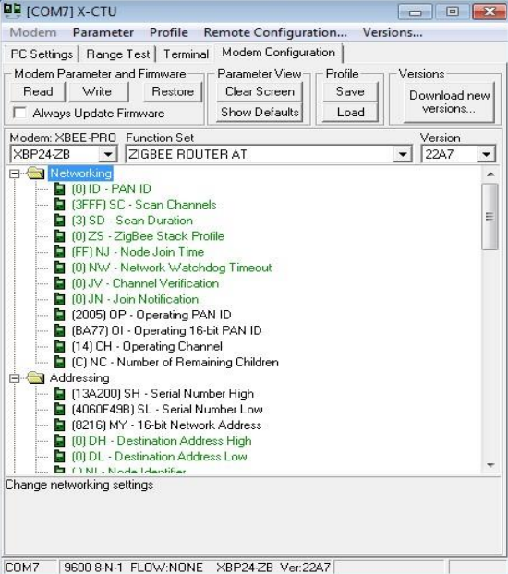

Once here, you want to select Zigbee Coordinator AT in the function set drop down menu.

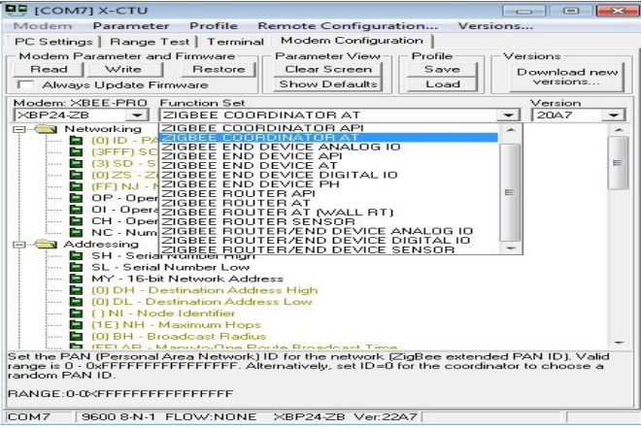

After selecting the coordinator function set, you will need to set the PAN ID. This can be any four-digit number and allows the XBees to distinguish between modules in their network and those from other networks. Once you have added the wanted PAN ID click the “Write” button. This will update and configure the XBee. Once this is done you can disconnect the XBee and plug in the second XBee.

**Step 4: Configure 2nd XBee as Router**

To configure the 2nd XBee, you will follow the same process as for the coordinator with one difference. In the PC settings tab, again, click the “Test/Query” button and record the serial number. Then in the Modem configuration tab, click the read button to load the current configuration of the XBee and set the PAN ID to the same ID used for the coordinator. The only change will be the function set you choose. For the second XBee we will set this as Zigbee Router AT.

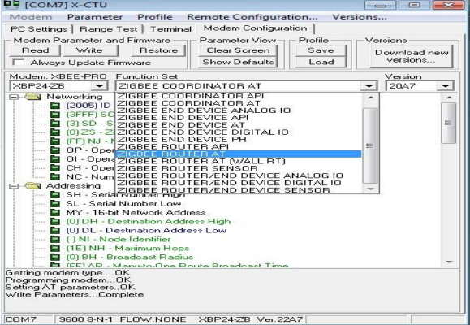

After setting the PAN ID and the function set for the router you will put the recorded serial numbers to use. Enter the first 6 digits of the coordinators serial number into the Destination Address High field and the rest of the serial number into the Destination Address Low field. Then select the “Write” button to update the configuration settings for the router. Once this is done updating you can disconnect the router and reconnect the coordinator to the computer.

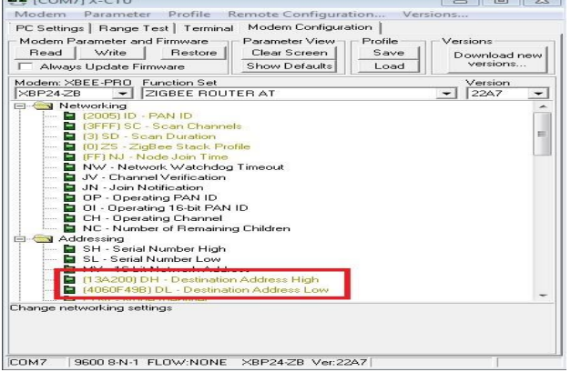

After re-connecting the coordinator to the computer. You will again go into the Modem Configuration tab and click the read button. You will then want to set the Destination Address to the serial number of the Router XBee in the same manner as you just did for the Router. Once done you will again click the write button to update the coordinator XBee settings. After the write process is complete you are ready to use your XBees and communicate wirelessly

**Step 5: Test the configuration**

A simple test can be done to be sure the two XBees are communicating properly. You can connect either one of the XBees to the computer. Then, connect the second XBee to 3.3V power and connect the Dout and Din pins together. This will cause the XBee to automatically retransmit any data it receives.

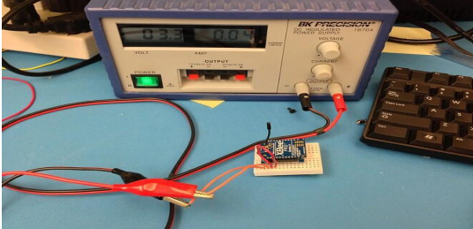

When you have both XBees connected go to the Terminal tab in the X-CTU window. Whatever you type in the terminal window will appear in blue font and whatever is received will appear in red font. If the XBees are configured correctly every character you type should be mirrored in red.

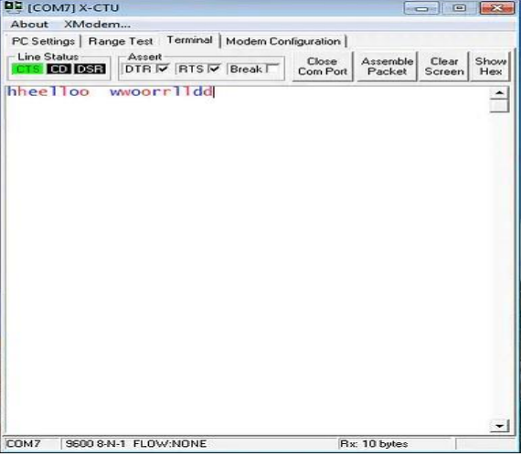

When typing single characters, you should see a screen similar to the one above. To send strings of data you can assemble a data packet. To do this click the “Assemble Packet” button and type the wanted string into the box then click send data. This will send the entire packet before receiving the same packet back.

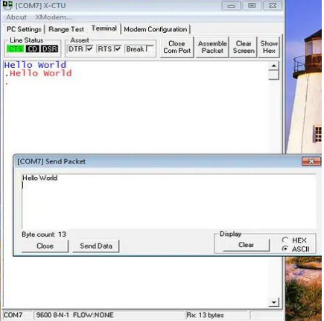

If everything you type is being reflected back in red, you are successfully transmitting and receiving with your XBees!! You are now ready to use them however you wish. You can connect them to any microcontroller and transmit data through the UART peripheral or you can connect each XBee to a different computer and have a chat application. There are many more possibilities that are now at your fingertips with your working XBees.

**Code:**

The code is quite straightforward. If you are using a board other than Arduino Uno, all digital pins may not support Software Serial.

On the transmitting side, the code will be –

#include<SoftwareSerial.h>

SoftwareSerial xbeeSerial(2,3); //RX, TX

void setup() {

Serial.begin(9600);

xbeeSerial.begin(9600);

}

void loop() {

if(Serial.available() > 0){

char input = Serial.read();

xbeeSerial.print(input);

}

}

As you can see, whatever the user on the Serial Monitor sends is sent to the XBee module, and it will be received on the receiving side. The code for the receiving side is –

#include<SoftwareSerial.h>

SoftwareSerial xbeeSerial(2,3); //RX, TX

void setup() {

Serial.begin(9600);

xbeeSerial.begin(9600);

}

void loop() {

if(xbeeSerial.available() > 0){

char input = xbeeSerial.read();

Serial.print(input);

}

}

##### **Circuit Diagram:**

